Monday - 2019 HSC ANSWERS
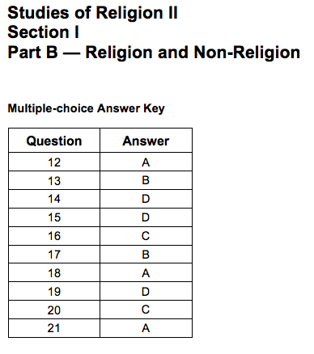
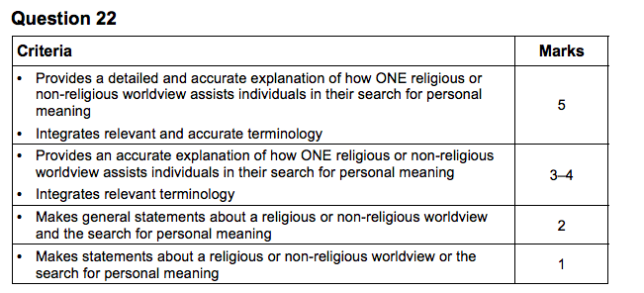

Sample answer:
Human beings have long sought answers from religious worldviews to the questions that
define who we are and the purpose of humanity. Islam is a religious tradition which provides
adherents with answers to the enduring questions of human existence. As Islamic
adherents search for meaning and depth in their life, they are provided with a structured
belief system that clearly answers what their purpose in life is, absolute surrender and
submission to Allah, and can be reassured that there is life after death, Akhira, or Paradise.
Through providing such definitive answers, Muslims are reassured about the complex issues
that cause great anxiety and worry in life. Islam offers a structured belief system and ethical
framework as well as a strong communal foundation. All of these aspects allow an adherent
to live fully, understanding their purpose, and realising why humanity was created and
continues.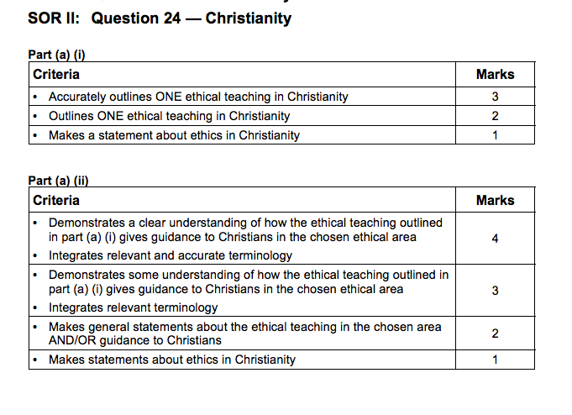
SIMILAR TO CHRSITIANITY SHORT ANSWER QUESTION FROM ASSESSMENT TASK 2
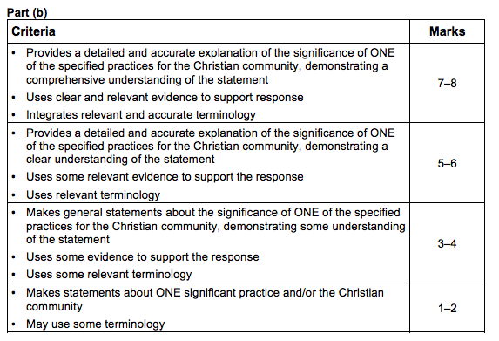

Apply quote to this info - In summary, Baptism is significant for the Christian community because it:
- is the means through which new members are admitted.
- strengthens the identity of the community as the Church, the body of Christ in the world.
- allows the community to affirm their commitment to the beliefs of Christianity and illustrates that Christianity is a living religion as the Trinity (particularly the Holy Spirit) is EVER PRESENT in the minds and hearts of the adherent and the community after they have been baptised.
- allows the community to support the faith life of the newly baptised - this is why many Churches insist on the baptism taking place during their official Sunday worship when the whole Christian community is gathered.

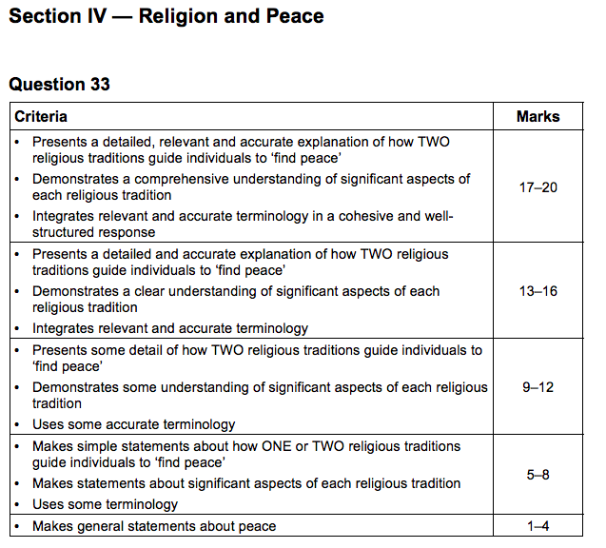
Answers could include:
Islam
• The Islamic understanding of peace is informed by the sacred texts and writings which
articulate principal teachings.
• The Qur’an is the foundational sacred text for all Muslims and contains extensive
passages that outline how inner and outer peace are connected.
• The Qur’an refers to Islam as the path to peace.
• Islamic adherents can look to the life and example of Muhammad and gain a deeper
understanding of peace.
• Inner peace is gained through practice, reading of sacred texts and absolute surrender to
Allah through the overcoming of nafs.
• Inner peace is inextricably connected to world peace.
• Living a life that includes meaningful prayer, enables adherents to reflect on their actions,
relationships with others and priorities in their own lives.

Christianity
• Christianity is a religious tradition that develops its understanding of peace through the
use of scriptures.
• Christians can review the life and example of Jesus to gain a deeper understanding of
peace.
• Peace is found in union with God. God established peace through his creation (as
described in Genesis).
• Inner peace is gained through communion with God, Christian practice and right
relationships with self and others.
• Inner peace is inextricably connected to world peace.
• The Christian understanding of love brings about peace.
• St Paul teaches about the role of love to achieve peace.
• The sacred scriptures of Christianity play a central role in understanding how Christian
peace is defined and understood.
• Living a life that includes meaningful prayer, enables adherents to reflect on their actions
and priorities in their own lives.

Tuesday - 2018 HSC ANSWERS

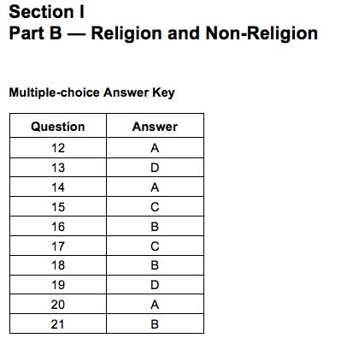
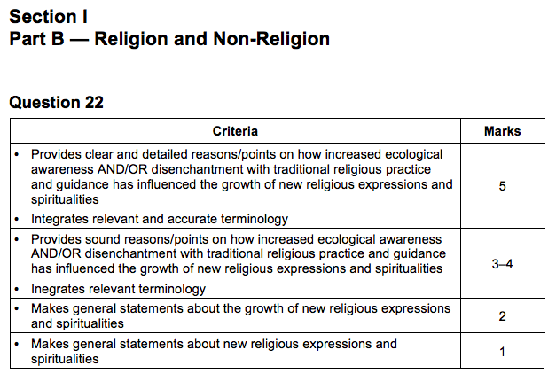
Sample answer:
Increased ecological awareness and disenchantment with traditional religious practice and
guidance are both influences which have contributed to the growth of new religious
expressions and spiritualities. Many individuals recognise the relationship between human
action and the state of the environment. Some have been able to achieve a sense of spiritual
freedom through a humble existence, choosing to live simply. Developing positive and life giving relationships with ecology can provide these individuals with purpose and meaning.
This has coincided with growing disenchantment with the conservative practice and guidance
of some traditional religious worldviews. The fixed nature of some of their ethical teachings
has led to disenchantment among adherents, especially in response to contemporary issues
such as gender equality and marriage. As a result, these individuals have sought out more
progressive spiritualities for liberal guidance towards purpose and meaning.

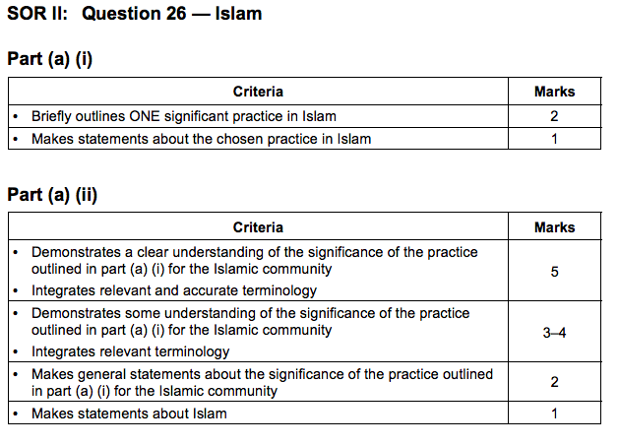
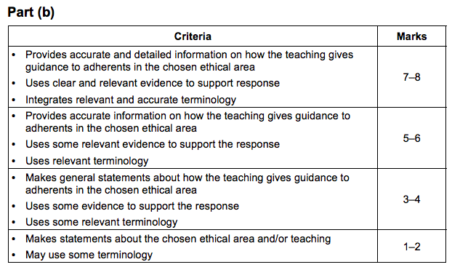
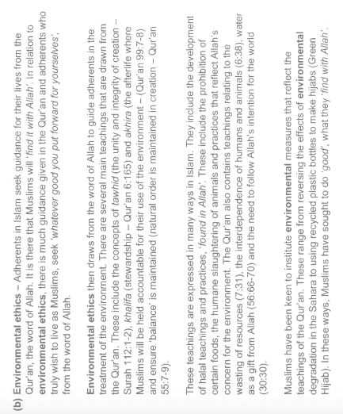

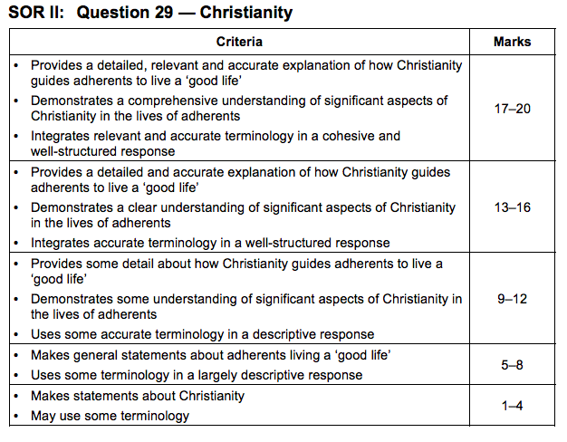
Answers could include:

Significant person
• Many significant people in Christianity have encouraged adherents to achieve a greater
unity with God by living ‘good lives’.
• To Paul, brought up under the rigid Jewish Law, God was pre-eminently the God of
Righteousness – of moral perfection.
• Paul gave very specific guidance to early Christian adherents on how to relate to others,
conduct their day-to-day affairs, and be led by the Spirit to live a ‘good life’.
• Paul specifically addressed moral sexual behaviour (Corinthians), the need for theological
clarity and accuracy (Colossians), and humility (Philippians) to guide Christian followers in
achieving fulfilling lives.

Significant practice
• The Christian marriage ceremony emphasises the roles of loyalty and commitment in
achieving fulfilling, life-long relationships.
• It emphasises the role of the Spirit in relationships and the importance of Spiritual maturity
in achieving a ‘good life’ through marriage.
• Through the living out of one’s marriage vows, couples grow to become more Christ-like,
not only with each other and their families, but in their attitudes and in their relationships
with the wider community.

Ethics
• Christian teaching on environmental ethics emphasises the need for earthly stewardship.
• Although the focus for Christian believers is the life to come, committed Christians
recognise and respect that the earth is part of God’s creation and must be nurtured for the
unselfish benefit of future generations.
• Activist roles by Christians, both in community environmental groups and groups with a
specifically Christian focus, plus statements by Christian leaders – Pope Francis’s
environmental statement Laudato Si – provide leadership for Christian adherents in living
‘good lives’ that will not only be fulfilling, but of great benefit to others.

Wednesday - 2017 HSC ANSWERS
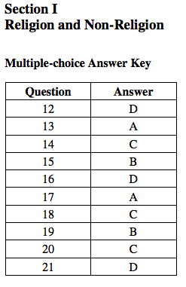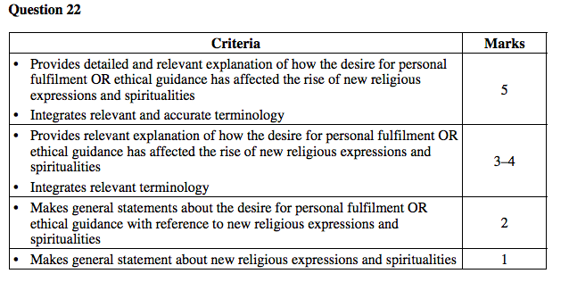
Sample answer:
The modern understanding of personal fulfilment has become increasingly influenced by
secular values and ideals. Whereas personal fulfilment may have been best expressed in the
past through traditional faith values such as family, acts of charity and so on, today’s society
motivates people to desire the acquisition of material goods, wealth or climbing the corporate
ladder to be fulfilled. These measures of personal fulfilment are in stark contrast to the basic
tenets of mainstream religions such as Christianity and Islam, which ask adherents to forgo
personal desire for the building up of the faith community to pursue a life of charity and
prayer in order to fulfil oneself in this life and to prepare oneself for the next life.
This contradiction between traditional sacred and contemporary secular ideas of personal
fulfilment has in part contributed to the rise in new religious expressions as people seek
something that ‘fits’ with the modern, secular understanding of personal fulfilment. An
example of this phenomenon can be seen in the emergence of Happy Science Australia.
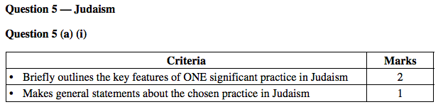
Sample answer:
One significant practice in Judaism is Synagogue Service. Synagogue Service assists Jews in
fulfilling the commandment to be faithful to God and to worship ‘no God but me’. Synagogue
Service makes the principal beliefs of Judaism evident through ritual.
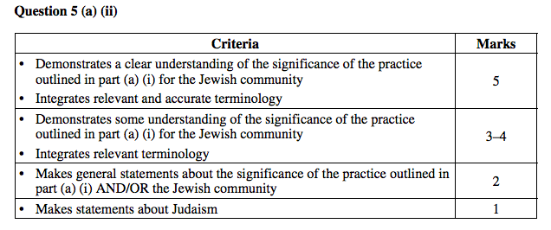
Sample answer:
Synagogue Service is a significant element in building up the Jewish community. As a key
component of the weekly Sabbath celebration, Synagogue Service draws the adherent into a
communal celebration. An essential requirement of the service is the Minyan (quorum of 10
men in Orthodox Judaism), requiring worship to take place in the context of community. The
reading of the Torah by members of the community serves to highlight milestones in
believers’ lives, for example the Bar Mitzvah and wedding anniversaries. Synagogue Service
is also significant for the Jewish community as it is a focal point for high holy days and
festivals, which often culminate in a synagogue service.

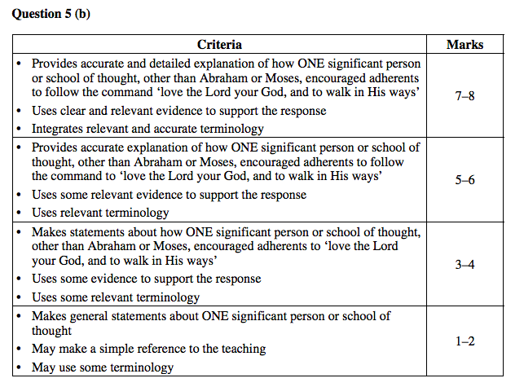

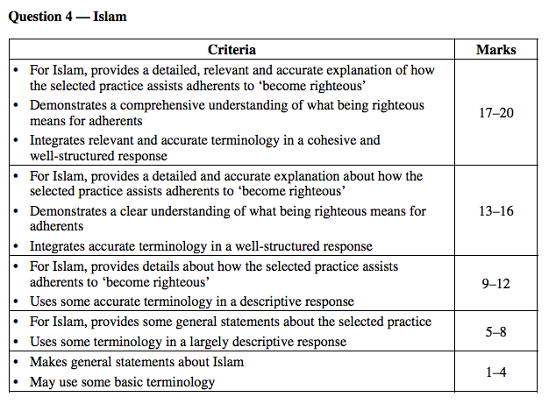

Answers could include:
Hajj
• The fifth pillar which is required at least once during an adherent’s life
• Pilgrimage is the supreme prayer for forgiveness of sins committed and the ultimate
preparation for eternity
• The Hajj is based on the foundation of the tradition involving a spiritual, mental and
physical journey to Mecca. All three elements would require an adherent to attain righteousness
• Hajj is a reminder of the equality of all people before Allah, as the individual will worship
Allah through submission to His will. This takes place through the ability to let go of external factors that may prohibit tawhid, such as family, friends and material possessions. Throughout the pilgrimage, this enables the individual to become righteous through focusing on the physical challenges of the Hajj
• The performance of rituals which mirror the actions of Muhammad and Hagar (among
others) during Hajj assists adherents to become righteous
• The undertaking of Hajj demonstrates a commitment to the greater jihad thus indicating the
adherent’s journey to become righteous
• The personal struggle to worship Allah assists an adherent to visibly support the promotion
and expansion of Islam. As a result, the adherent is assisted in becoming more righteous.

Thursday - 2016 HSC ANSWERS

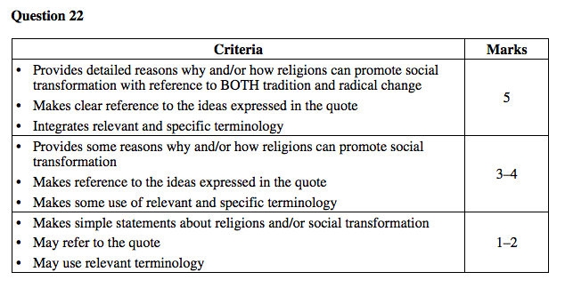

Sample answer:
Throughout history, religions have relied on their traditions to bring about social
transformation. Radical change can come when a religion remains true to the roots of their
social justice principles while keeping in touch with a modern changing world. For example,
a Jewish scholar who seeks guidance from sacred text to motivate their decisions regarding a
modern social issue such as reproductive technologies or asylum seekers. Also, identifying
past errors and using them to make lasting changes such as Christian groups working for
Ecumenism.

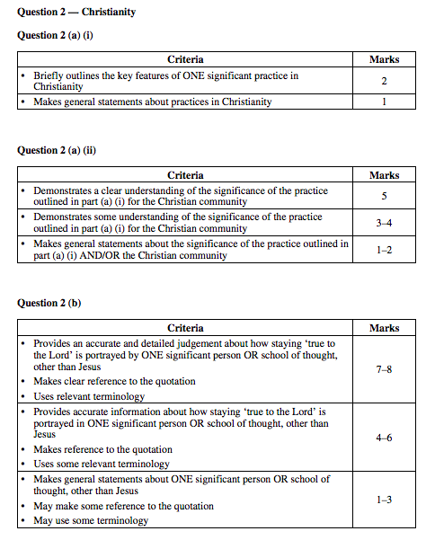

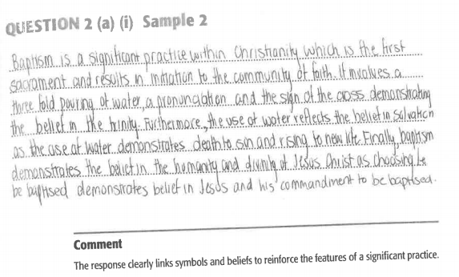

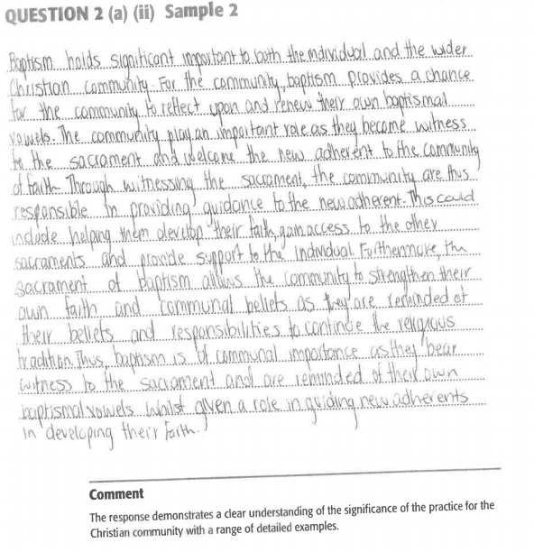

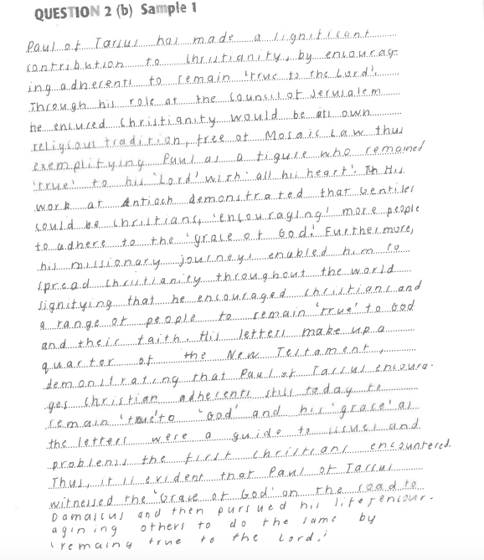
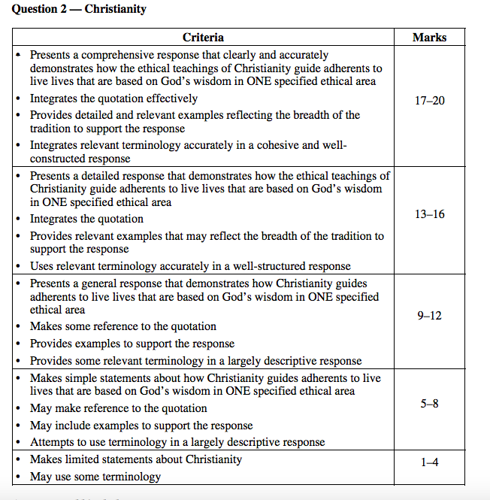
Answers could include:
Sources of ethical teaching in which Christian beliefs are reflected:
• Scripture (Decalogue, Sermon on the Mount, the Great Commandment):
• In Catholicism, Natural Law, teaching authority of the Church, informed conscience
• In Reform Protestant tradition: personal autonomy before God, opinion of scholars in
Christian ethics, discernment in the believing community, church documents to guide and
inform but not oblige adherents
Christian ethical teachings vary both within and between Christian denominations. Some
variants strongly rely on the use of authority (eg the teaching Magisterium in the Catholic
tradition; the Bible or the ‘Bible only’ (sola scriptura) in some Protestant denominations).
Some place a reliance on natural law, while others develop their ethical positions from both.
Hence, a range of different ethical responses that focus more directly on either justice or
compassion is a logical outcome of the varying theologies of the variants.

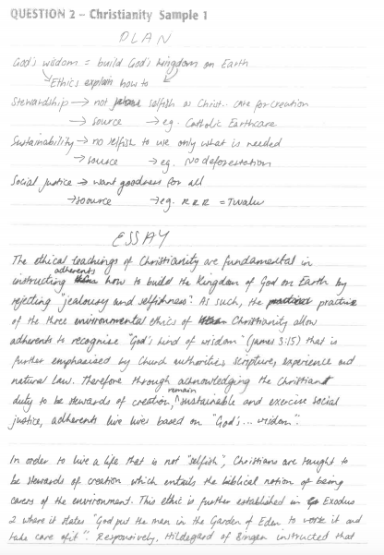
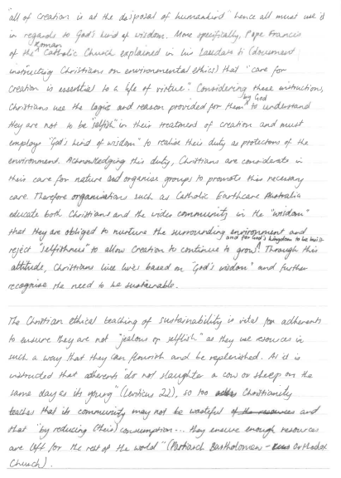
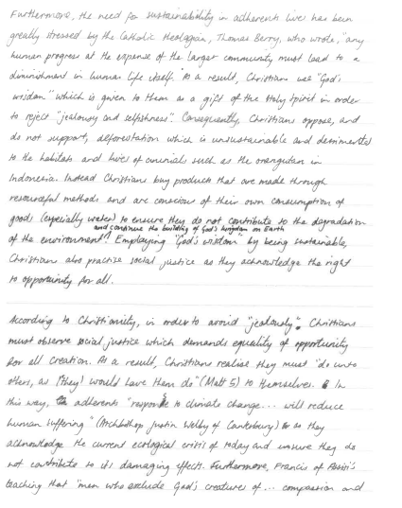
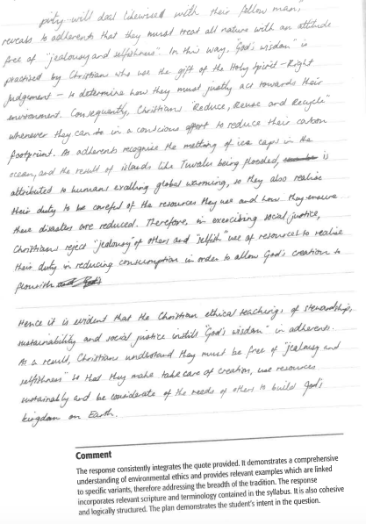
Friday - 2015 HSC ANSWERS
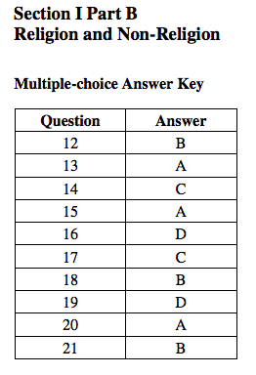
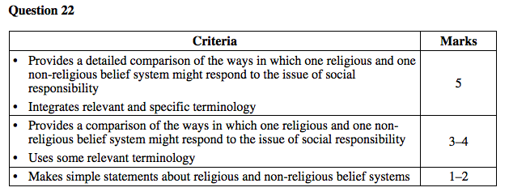
Sample answer:
A Christian and an atheist respond to social responsibility differently. A Christian would
argue that, as part of a community built on a set of beliefs, practices, ethics and texts, social
responsibility is intrinsic to their identity. A baptised Christian, initiated into the belief
system, will attempt to live their life according to God’s instruction, such as assuring the
preferential option for the poor, whereas an atheist would look after others in order to give the
best opportunity for humans to live a life fulfilled. The atheist would argue for just laws to
protect the poor and create equality for all to ensure all life is cared for in order for humanity
to live harmoniously.

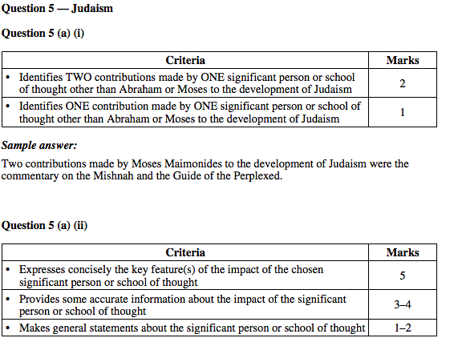
Sample answer:
Moses Maimonides’ (RaMBaM) impact on Judaism was great. His writings allowed the
common person to access the scriptures in their own language. This helped the Jewish people
to be able to observe the laws and the covenant more easily as they could read and understand
it for themselves. His commentary on the Mishnah opened the scriptures to the people of the
time and Jews today.
Moses Maimonides was also able to rid Judaism of superstitions. He did this by having the
writings easily read and understood by all. He influenced many others in their work and
writings, particularly Moses Mendelssohn. Many today see Maimonides as defining the
essence of what each and every Jew should be doing when faced with demands of both their
everyday work and Torah study, in particular, that Torah study should have a place in their
busy lives. His writings have guided Jews for centuries and his writings have been
incorporated into most Jewish prayer books.

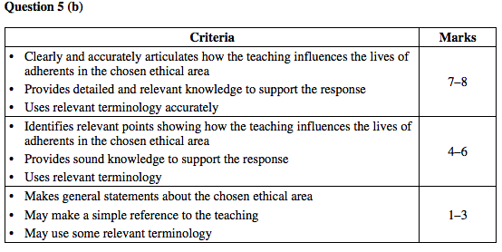
Sample answer:
Environmental ethics is an attempt to define a system of values to guide human interaction
with the natural world. In Judaism, environmental ethics is based on the Hebrew Scriptures.

The Hebrew Scriptures, Talmud, Midrash, and other Jewish sources contain literally tens of
thousands of references to environmental concerns.

The Hebrew Scriptures contain numerous references to environmental concerns and show
how God wants adherents to live their lives in a manner that would be following God’s way.
Jews believe ‘God’s way is in holiness’ and being environmentally aware is a holy way or
practice. The prophets in the Jewish Scriptures reinforce that “God’s way is in holiness”.

They warn of the catastrophe that will result from contamination of the land. From the
Hebrew Scriptures, Judaism has seen humans as lords of creation, but at the same time
needing to be deeply grateful to God for the sustenance creation brings and, therefore, be
responsible for its stewardship.

Psalm 24:1 states ‘The earth is the Lord’s and all that is in it, the world, and those who live in
it’. This scripture reference reinforces ‘God, your way is in holiness’. Humans were created in
God’s image (Gen 2) so they are called to be creators in the world, not destroyers.

The Talmud further understands that nothing was created by God without a purpose, thus the
whole of creation is deserving of respect and appropriate care. This is again shown in Psalm
77:13 “God, your way is in holiness.”

The Bal tashchit (Do not destroy) found in the Hebrew Scriptures demands that a Jew follows
what God has asked. Thus, this reinforces Psalm 77:13 ‘God, your way is in holiness’. In
Judaism, the teaching to not destroy applies to all areas of God’s creation.

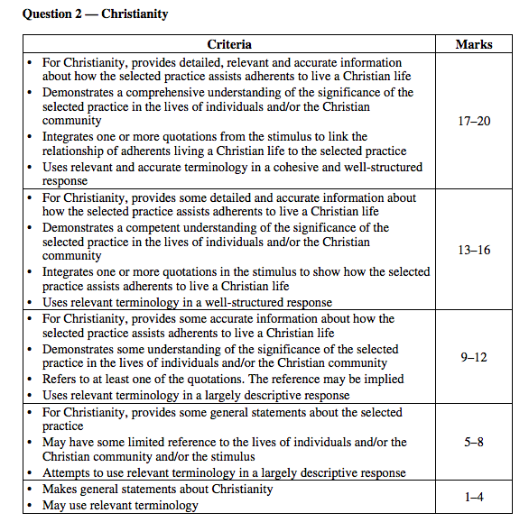
Answers could include:
• Baptism assists individuals and the Christian community to live a Christian life.
• When an individual is baptised he/she is initiated into the whole Christian life.
• As the quote states ‘Anyone who belongs to Christ has become a new person. The old life
is gone, a new life has begun,’ individuals are initiated into a new Christian life that is
guided by the Holy Spirit. The individual is reborn as a child of God and becomes a
member of the Church and shares in its mission.
• Baptism also initiates a candidate into the Christian community. It not only moves an
individual from ‘an old life’ to begin a ‘new life’, it moves an individual into a life in a
Christian community.
• By moving an individual into a Christian community, baptism assists one to live a
Christian life. ‘For where two or three gather together as my followers, I am there among
them’. This quote is fulfilled by being baptised into the Christian community. A
community enjoys the ongoing presence of God.
• Baptism assists the community to live a Christian life by allowing the gathered
community, ‘for where two or three gather together as my followers, I am there among
them’, to witness a new adherent’s entrance into the Christian community.
• In some denominations, the baptised individual and the community recite their Baptism
promises. This is part of Christian life as the Baptismal promises are renewed each year in
the creed and during Easter liturgy.
• During baptism an individual has a sponsor or godparent. These are firm believers and
witnesses who assist the newly baptised on the winding road of Christian life. The
community is more than ‘two or three’ people and has Christ ‘among them’. The ‘new life’
of the baptised individual is supported by the community on the journey to live a Christian
Life.
• The Christian community bears some responsibility for the faith life of the newly baptised
Christian. That is why many Christian churches insist that the actual rite of baptism take
place during their official Sunday worship when the whole Christian community is
gathered.
• When they are baptised they share in living a life that has a specifically Christian focus.

SAMPLE RESPONSE
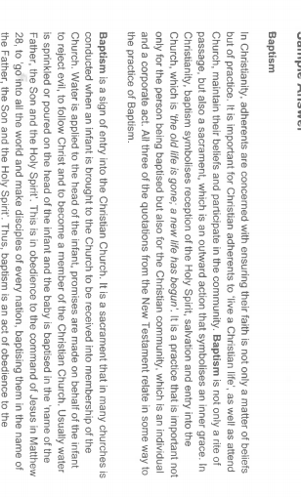

Monday - 2014 HSC ANSWERS

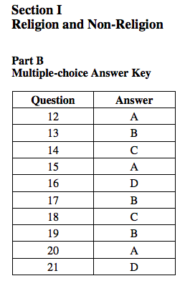
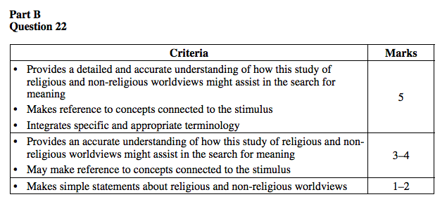
Sample answer:
This person has taken different subjects that include religious and non-religious worldviews.
This course of study might assist a person in his/her search for meaning. By studying areas
such as Atheism and Rethinking Religion she/he would be able to recognise how nonreligious worldviews help the individual’s search for meaning. By studying Religion and
Ethics and Religion in a Materialistic world, a person would be able to see how religious
worldviews help the individual’s search for meaning.
In Religion and Ethics which is a Religious worldview, a person would learn that a religion
such as Christianity sees all humans as created in the image of God and therefore a human is
bound to treat others according to that belief. There is a responsibility for people to build a
just society in which everyone is provided with the means of living with dignity and respect.
This clearly would assist a person in his/her search for meaning. However Science (a nonreligious worldview) sees that humans are able to discover through study and reason how best
to live in society. Science demonstrates that humans need each other and that relationship is
important for the development and growth of an individual. This non-religious view is similar
to a religious worldview but argues human connections would assist a person’s search for
Meaning.

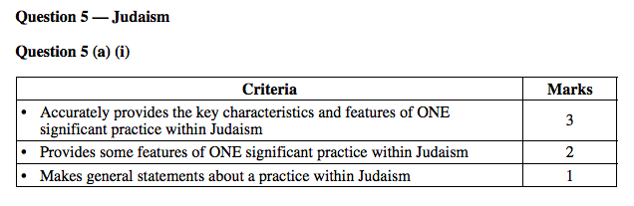
Sample answer:
Synagogue services are held in a synagogue known as the house of prayer (beit tefillah).
Synagogues are also meeting houses and houses of learning.
In Judaism it is considered important to pray within a community and a minyan (ten) must be
present for certain prayers. Synagogue services are a way the community can join together in
prayer.

Synagogue services are led by a rabbi and in Orthodox services they are said in Hebrew. The
shabbat service is the obligatory service that begins on Friday evening and ends on Saturday
evening but services are held every day. Special services are held to mark festivals.
Prayer services are held three times a day in a synagogue. These are the morning service (the
longest prayer), afternoon service (the shortest prayer) and the evening service (after sunset).
There are two types of synagogue services: Ash Kenazi and Sephardi. Prayers are found in the
siddur (Jewish prayer book).

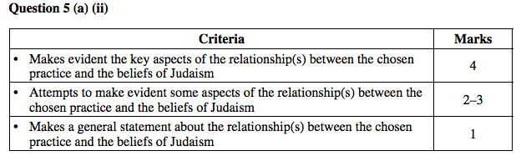
Sample answer:
Prayer services in Judaism express the beliefs of Judaism. Prayer services conducted at the
synagogue are strongly connected to stories from the Torah. The Torah is the Law and the
main source of belief for Jewish people. Synagogue worship focuses on the Torah and the 613
mitzvot in the Torah. Jewish belief that God must be worshipped is expressed in the
synagogue by retelling the stories from the Torah.
The morning prayer service (shacharit) follows the traditions of Abraham. In Genesis 22:3
Abraham arose early in the morning. Hence the belief of praying in the morning. Morning
prayer contains the Shema which is directly linked to the beliefs of Judaism. The Shema is the
central prayer of morning services. This is an affirmation of Judaism and declaration of faith
in one God. The Aleinu prayer is also prayed which includes hope in seeing the one God in
his mighty splendour. This again is a belief of Judaisim.

In the afternoon service (Mincha) is a link to Isaac. In Genesis 24:63 Isaac went out
meditating to the field towards evening. The afternoon prayer is where Psalm 145 is recited.
The concept of these prayers is to come closer to God. The Aleinu prayer is again prayed in
the afternoon again expressing the beliefs of Judaism.

The evening prayer follows the tradition of Jacob. In Genesis 28:11 Jacob came upon a
certain place and stopped there for the night. The Shema and the Aleinu are prayed at this
service. The prayer services are substitutes for the sacrifices made in the Temple of Jerusalem
prior to its destruction in 67/70 CE. The evening prayer begins just before sunset because the
Jewish day begins and ends at sunset. The centre of this prayer is the reading of the Torah.
The whole Torah is read from beginning to end in 12 months.

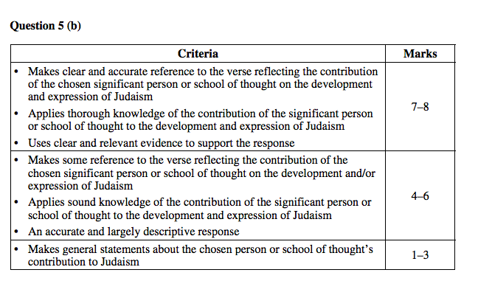
Sample answer:
Moses Maimodies (Ramban) contributed greatly to Judaism. He wrote several books such as
the Mishnah Torah, the Guide to the Perplexed, and the commentary on the Mishnah. He
wrote the Mishnah Torah which contained Jewish Law for all ages and places. In this book
ordinary Jews or non-Jews were able to access the Jewish Law in language easily understood.
The quote states one must “love the Lord your God, keep His charge, His statutes, His
ordinances and His commandments”. If people were unable to understand the law written in
complicated verse how could they “keep his commandments”. Moses Maimodies’s greatest
contribution to Judaism was assisting ordinary Jews and non-Jews to access the Laws.
Lay people who used the Mishnah Torah could understand the laws more easily without
having to refer to lengthy Talmudic study, therefore being able to “keep (his) commandments
all the days”. They were able to keep “His charge” as they could understand what was asked
of them.

The term Mishnah Torah means “The Second Law” and is the name given to the Book of
Deuteronomy. The Mishnah Torah recognises and reformulates the laws in a clear and logical
system. Early writings were haphazardly arranged and were difficult to follow. If one was to
“keep his commandments” one would need to understand them and be able to follow them in
some order.

When Maimonides wrote the Commentary on the Mishnah he wrote it in Arabic, the everyday
language of the Jews under Muslim rule, so that the Mishnah would be understandable to
Jews. Again for Jewish people to be able to keep “His commandments all the days” they
needed to understand and be able to read them.

After 10 years of work Maimonides completed the 14 volumes of the Mishnah Torah which
distilled the Talmud and all the responses of the Jewish scholars into a simple code that the
lay person could understand.

Of great importance to Judaism Maimonides’s “Thirteen Articles of Faith” were a guide to the
principal beliefs of Judaism for centuries. For the everyday Jew the principal beliefs of
Judaism were reduced to 13 articles of faith which were easier to understand and follow.

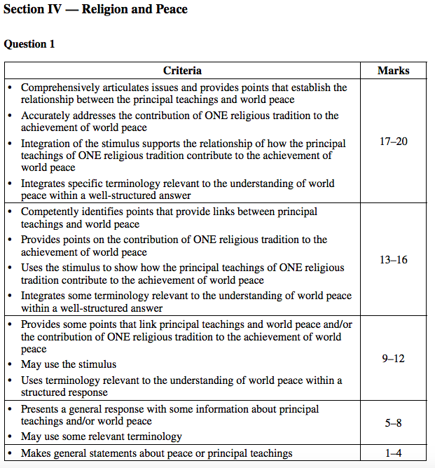

Answers could include:

Notes from the stimulus
• Confront hostility
• Reaffirm common humanity
• Pave the way for greater tolerance
• Solidarity among groups
• Enormous potential of religion to foster true peace

Tuesday - 2013 HSC ANSWERS

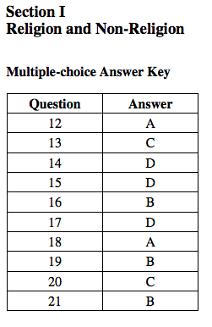
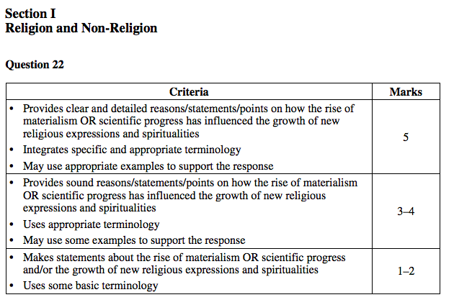
Sample answer:
The rise of materialism has influenced the growth of new religious expressions and
spiritualities in a number of ways. Some of these new spiritualities embrace materialism,
while others reject them.
The rise of materialism in the late twentieth century with the focus on the accumulation of
possessions and wealth has become a significant goal of some new religious expressions.
Some Evangelical Christians endorse the ideas of ‘prosperity doctrine’ while other new
religious expressions promote self-help courses to assist in the accumulation of material
wealth. Prosperity is seen within the expressions as a form of blessing or validation of the
individual and the community. Material success can be viewed as a reward for spiritual
application.
The materialistic nature of some mainstream churches (or indeed secular society) has caused
some to seek out new religious expressions that reject materialism. The desire for a simpler
life, free from the pressures of financial woes has led to the creation of spiritual communities
that focus on communal sharing, self-sufficiency and even radical poverty. Some of these
expressions have their origin in forms of animism that have focused on the natural world and
spiritual power (eg Wicca) rather than the material world and financial power. Other
expressions are loosely based on Eastern religions (eg Hare Krishna) that have also
traditionally focused on simplicity and mysticism rather than materialism.

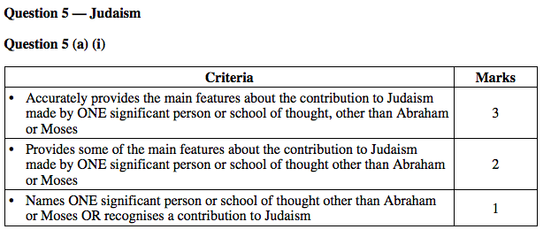
Sample answer:
Moses Maimonides made a contribution to Judaism as a writer, teacher, leader, philosopher
and theologian. He wrote the Thirteen Articles of Faith providing the principal beliefs of
Judaism. Maimonides also wrote the Mishneh Torah and the ‘Guide to the Perplexed’,
contributing to the history and development of Judaism. His ten medical works, written in
Arabic, contributed to the medical understanding of the era.

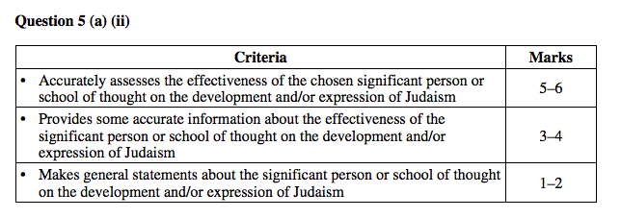
Sample answer:
Moses Maimonides (1135 – 1204) was an extremely effective teacher, writer, leader,
philosopher and theologian in Jewish history. He was very effective in the development and
expression of Judaism and is still relevant today. Maimonides wrote a significant number of
books and writings as well as leading a life modelling his Jewish beliefs. His works have been
published in many languages.
These written works were accessible to laypersons in a language that could be interpreted and
understood. In 1158 he wrote a commentary on the Mishneh in Arabic – the everyday
language of Jews living under Muslim rule. This provided accessibility without lengthy
Talmudic study for these people.
His works provided a guide for Jewish people. His Thirteen Articles of Faith provide the
principal beliefs of Judaism and are referenced in the Siddur (Jewish Prayer Book).
His ‘Guide to the Perplexed’ contributed enormously to the history of philosophy of the
Middle Ages as well as the rational development of Judaism. Moses Maimonides believed
that a knowledge of the Torah should not provide a person with income. So while living in
Cairo he became a physician and in 1185 physician to the Sultan. During this time he wrote
ten medical books in Arabic. These books and others were considered great contributions to
the development of Judaism in his time and to the present.
The Mishneh Torah was very effective, assisting in both the development and expression of
Judaism. It provided the full range of Jewish law for all places and all times. It reformulated
and reorganised the laws in a clear and logical system. It included writings of Aristotle and
Muslim philosophers resulting in much dialogue and sometimes opposition from Jewish
leaders.

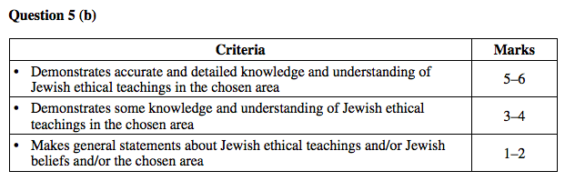
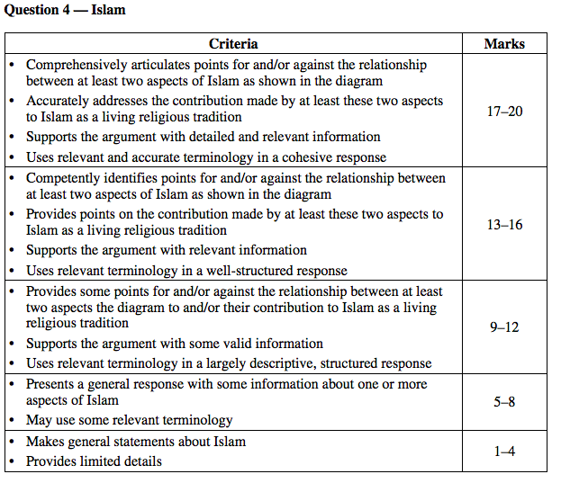

Wednesday - 2012 HSC ANSWERS
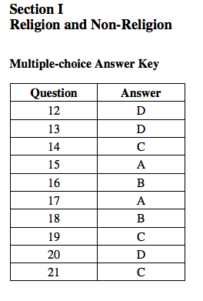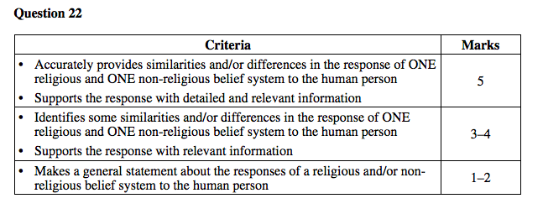
Sample answer:
Religious and non-religious belief systems have significantly different views on the
understanding of the human person. Both humanists and Christians believe in the dignity of
the human person. Christianity believes in the existence of a soul whereas humanists view the
human person as the highest form of life.
The Christian belief system draws its moral teachings from its own religious authorities (eg
the teaching Magisterium of the Catholic churches) and sacred texts. Humanists, however,
view humanity as the dominant life form and, as such, it can determine its own values. Unlike
humanism, the Christian belief system believes in the existence of an afterlife and the need to
follow the will of God, and this belief affects human behaviour.
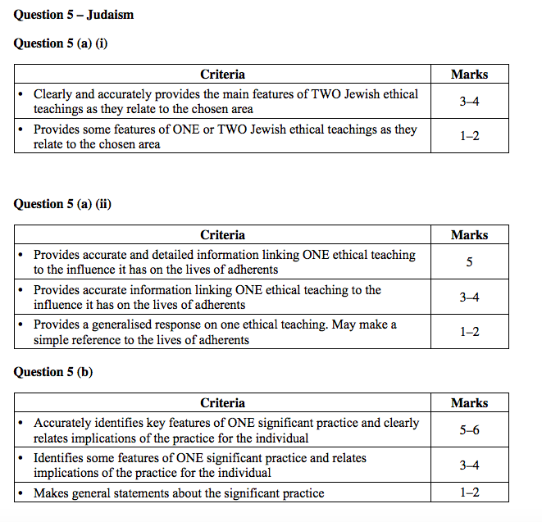
(a) (i) In better responses, candidates clearly provided the main features of two Jewish
ethical teachings. These candidates supported their response with correct terminology
and scriptural references from the Torah and/or Talmud.
In mid-range responses, candidates focused on the issue rather than the ethical
teaching. They may have provided some reference to sacred texts when discussing the
issue.
In weaker responses, candidates listed the ethical issues and made limited, if any,
mention of one ethical teaching. In these responses, candidates lacked Jewish/Hebrew
terminology and failed to mention sacred texts or scripture.

(a) (ii) In better responses, candidates provided detailed accurate information to link one
ethical teaching selected in part (a)(i) to the influence it has on adherents. The link was
made explicit through the use of current examples and sophisticated terminology.
In mid-range responses, candidates did not make a clear link to the ethical teaching
but concentrated on the issue and its influence on the adherent.
In weaker responses, candidates simply discussed the issue, making limited, if any,
reference to the life of the adherent.

(b) In better responses, candidates accurately identified key features of a significant
practice and clearly related these features to implications for the individual. In these
responses, candidates made explicit reference to the practice, supported by solid links
to sacred texts and writings, and also included identification of significant symbols
and actions. Candidates used sophisticated terminology appropriate to Judaism in
these responses.
In mid-range responses, candidates either focused on the significance of the practice
for the individual without making any link to the features, or concentrated on the key
features without relating the implications for the individual. The analysis and
terminology in these responses was limited.
In weaker responses, candidates made no reference to the individual and often lacked
accurate information.

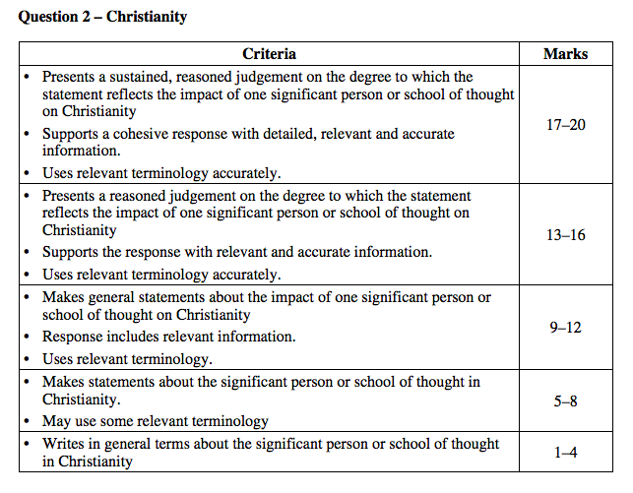
Question 2: Christianity
In better responses, candidates engaged thoughtfully with the question and challenged what
‘reform’ and ‘revitalisation’ actually meant in relation to the significant person or school of
thought chosen. Regardless of whether candidates agreed fully or in part with the stimulus,
they presented a critical judgement explicitly supported by specific scripture references, other
writings and examples. The information presented was accurate, relevant and well integrated
into the response. In these responses, candidates wrote objectively, and were comprehensive
in detail and cohesive in structure.
In mid-range responses, candidates made some reference to the statement but were not
explicit enough in presenting a reasoned judgement; that is, they did not go far enough to
show how the person or school of thought reformed or revitalised the Christian religious
tradition. In these responses, candidates discussed the impact of the person or school of
thought, but showed no real understanding of the terms ‘revitalised’ and ‘reformed’.
Information presented was largely descriptive and relevant, but the responses lacked detail. In
these responses, candidates did not provide enough evidence to imply a sustained, reasoned
judgement. They often lacked coherent structure.
In weaker responses, candidates presented information about a person or school of thought
that was largely biographical and lacking in accurate detail. In some responses, candidates
discussed ethics or practice without any links being made to the person or school of thought.

Thursday - 2011 HSC ANSWERS
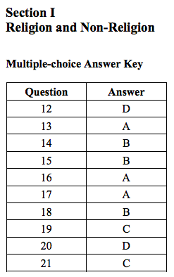

Question 4 (a)
Answers could include:
A’isha Bint Abu Bakr
• Chose poverty and fidelity over wealth/marriage
• Passionate about education, especially for women
• Compassionate care of orphans and foster children
• Recorded and preserved material that was basis of the Hadith
• Distribution of riches to the poor – model for Zakat
• Strong, intelligent, independent Muslim woman
Question 4 (b)
Answers could include:
A’isha is a model of intellect and independence in women while remaining a faithful Muslim.
• The Hadith has become a text that offers models of desirable attitudes and behaviour, and a
guide for decision-making in Islam.
• A’isha’s life and contribution offers a model for women in Islam.
• A’isha’s life and contribution offers resources to Muslim women that provide alternatives
to negative stereotypes of Muslim women.

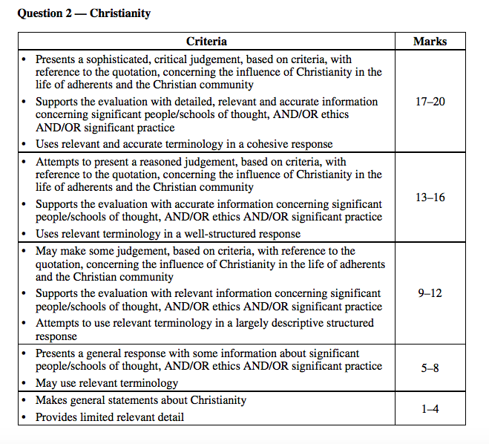

Friday - 2010 HSC ANSWERS
Question 22:
Answers could include:
Individuals seeking a life enriched with significance and meaning through involvement in the
following:
• actively caring for the poor and disadvantaged – both locally and globally
• social justice – seeking a role in government/politics, law etc. to have an impact; seeking to
influence government policies as a member of an activist group
• involvement in community service initiatives eg, Night Patrol, Missionbeat
• seeking clarification and answers to life questions such as ‘where do I go when I die?’ and
‘is there a God?’
Communities and religious institutions seeking to have a positive impact on human
communities:
• providing clear moral and spiritual guidance
• pressing governments to adopt socially just principles
• advocating for changes in society to improve the living standards and conditions of all
people
• providing services that actively help the community, including hospitals, aged care,
facilities for drug/alcohol/sexual abuse/homeless (eg Teresa House, Sydney City Mission,
Salvation Army, The St Vincent de Paul Society), schools, counselling (eg Lifeline),
charitable organisations administered by religious groups
• providing adherents with a community of people to turn to in times of need.

Question 4 — Islam
Question 4 (a) (i)

Sample answer:
Hajj
• The Fifth Pillar – required at least once during a lifetime
• Pilgrimage is the supreme prayer for forgiveness of sins committed and the ultimate
preparation for eternity
• Pilgrimage rituals which must be performed, eg circumambulation of the Ka’ba
• The rites of the Hajj symbolise the essential concepts of Islam and commemorate the trials
of the Prophet Ibrahim and his family.

Question 4 (a) (ii)

Sample answer:
Beliefs
• Muslims believe the Qur’an is the word of Allah and therefore undertaking the Hajj is
God’s command
• Muhammad performed many pilgrimages throughout his life. He is the final prophet and
therefore a role model whom people should attempt to emulate
• Belief that Adam fell from grace by giving into temptations, after which he came to his
senses and received forgiveness from the merciful God. Muslims practise Waguf on the
third day, reminiscent of the three temptations. Waguf is standing before God seeking
forgiveness
• During Hagar and Ismail’s searching for water she drank from the Zamzam well which
was created by God; modern-day Muslims collect this sacred water and sanctify their
burial shrouds
• Plain of Arafat believed to be the place where people will be judged, and is central to the
Hajj where Muslims pray and reflect on their lives
• The Hajj expresses numerous beliefs about prophetic heritage (risalah) of Islam prior to
Muhammad
• The central belief of Tawhid and also Akrah feature predominantly
• For Shi’a the Hajj is central to their beliefs and expression of Islam, but forms part of a
greater pilgrimage.

Question 4 (b)
Sample answer:
Environmental ethics
• Established on the principles set forth in the Qur’an which both Shi’a and Sunni variants
accept as the direct word of God. The Qur’an is uniformly accepted and interpreted by all
Muslims to reflect its importance in understanding that conservation of the natural
environment is a moral and ethical imperative
• The Hadith is an important second authority for Islamic environmental ethics. It is a
tradition which has been compiled by various Muslim scholars intending to document the
movements of the prophet; however, conflict in interpreting this source reinforces the
importance of the Qur’an
• Shari’a Law involves Islamic jurisprudence, formulating policies in regard to the
environment based on the principles enunciated in the Qur’an and Hadith
• The disagreements on the source of Islamic laws other than the Qur’an have caused
conflict in understanding how Islam as a whole should confront the current ecological
crises
• Khalifa is the notion of trusteeship, that we are ‘custodians’ of the created world. The
Qur’an, together with Hadith, emphasises our role as guardians using the world’s resources
in a suitable manner
• Tawhid refers to the oneness of Allah which by extension encompasses the created world
• Akrah refers to all being accountable for their actions including those against the
environment.

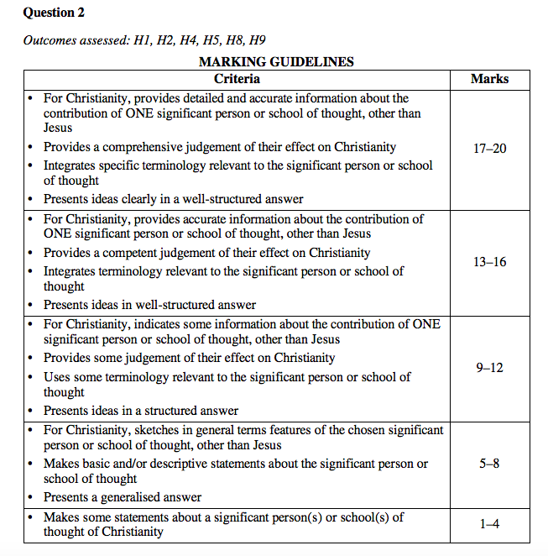
High-range responses provided detailed and accurate information about the contribution of the individual or school of thought and were able to link this, quite specifically, to the effect that it had on Christianity. It was the assessment of this aspect rather than biographical details or narrative that formed the crux of the question. The best responses were comprehensive in their assessment and were able to demonstrate an understanding of the continuing effect across the whole tradition where relevant. Similarly, candidates who presented a school of thought were able to draw on a range of examples from within the school to support their responses.

