School/College

2019 |  | TRIAL  HIGHER  SCHOOL  CERTIFICATE EXAMINATION
Mathematics Standard 2

General Instructions | - Reading time – 5 minutes  - Working time – 2 hours and 30 minutes  - Write using black pen  - Approved calculators may be used  - A reference sheet is provided at the back of this paper  - In Questions in Section II, show relevant mathematical reasoning and/or calculations
Total marks : 100 | Section I – 15 marks (pages 2 – 9)  - Attempt Questions 1 – 15  - Allow about 25 minutes for this section  Section II – 85 marks (pages 10 – 40)  - Attempt Questions 16 – 49  - Allow about 2 hours and 5 minutes for this section

Section I
15 marks
Attempt Questions 1–15
Allow about 25 minutes for this section

Use the multiple-choice answer sheet for Questions 1 – 15
An undirected network with vertices I, J, K L, M and N is shown below.

Which term could not be used to describe the highlighted section J I L K M ?
(A) a cycle
(B) a path
(C) a tree
(D) a walk
A type of car number plate has two letters, followed by two numerals, followed by two more letters.
For example

Which calculation would give the total number of number plates of this type which begin with the letter C?
(A)
(B)
(C)
(D)
The graph shows the relationship between the time taken for a given journey (T), and the average speed of the journey (S).

The driver maintained the speed limit of 100 km/h for the entire journey.
What is the shortest time in which she could have completed the journey?
(A) 8 minutes
(B) 32 minutes
(C) 40 minutes
(D) 48 minutes
Shaun earns a salary of $125 400 and has allowable tax deductions of $2 148.
Use the able below to calculate how much income tax Shaun should pay, not including the Medicare levy.

Taxable income | Tax on this income
0 – $18,200 | Nil
$18,201 – $37,000 | 19c for each $1 over $18,200
$37,001 – $90,000 | $3,572 plus 32.5c for each $1 over $37,000
$90,001 – $180,000 | $20,797 plus 37c for each $1 over $90,000
$180,001 and over | $54,097 plus 45c for each $1 over $180,000

(A) $31 603.90
(B) $31 747.00
(C) $33 100.24
(D) $ 33 895.00

The formula to provide an estimate for blood alcohol content for females is :
- where 𝑁 is the number of standard drinks consumed, 𝐻 is the number of hours of drinking, and 𝑀 is the person’s weight in kilograms.
Florence, who weighs 64 kg, has her BAC measured at 0.08 after drinking for three hours.
How many drinks did she have according to the formula?
(A) 3
(B) 4
(C) 5
(D) 6
In
Calculate the value of

(A) 67
(B) 113
(C) 132
(D) 138

Torey lists the costs of running his car:
- Registration - $378.00 annually
- CTP insurance - $546.00 annually
- Comprehensive insurance - $460.00 annually
- Mechanical service and repairs - $450.00 every three months
- Petrol and consumables - $40.00 per week
He wants to put money into an account each week to cover these costs and allow an extra 10% contingency in case of unforeseen expenses.
How much (to the nearest dollar) should he deposit each week?

(A) $89.00
(B) $101.00
(C) $102.00
(D) $111.00
The scatterplot below has been drawn to compare two variables x and y.

How could the relationship between the variables be described?
(A) A strong linear relationship
(B) A strong non-linear relationship
(C) A weak linear relationship
(D) A weak non-linear relationship

The cost of the weekly groceries for the Hart family in January 2016 was $228.00.
Since 2016, the inflation rate in Australia has averaged at 1.9% p.a.
If this rate continues, what will be the cost of their weekly groceries in January 2020?
(A) $229.90
(B) $232.33
(C) $245.33
(D) $245.83
Find the area of the sector of a circle shown below.

(A) 134 cm²
(B) 354 cm²
(C) 7391 cm²
(D) 7611 cm²

Essie invests $6 400.00 at a simple interest rate of 9.6% p.a. for a period of 5 months.
How much interest does she earn?
(A) $256.00
(B) $307.20
(C) $2 560.00
(D) $3 072.00
Samuel’s exam results in four subjects are shown in the table below.
Subject | Mean | Standard Deviation | Samuel‘s mark
Biology | 60 | 12 | 78
English | 55 | 10 | 65
Maths | 65 | 15 | 80
Society & Culture | 80 | 14 | 87

In which exam did Samuel perform best in comparison to the other students who sat the same exam?
(A) Biology
(B) English
(C) Maths
(D) Society and Culture

Which equation describes the graph below?

(A)
B)
(C)
(D)
Which is the graph of
(A) (B)

(C) (D)

The network below shows the roads connecting nine villages labelled A to I.
The weights on the edges are the average travel times (in minutes) between adjacent villages.

What is the minimum travel time from B to H?
(A) 31 minutes
(B) 33 minutes
(C) 36 minutes
(D) 37 minutes

School/College
2019 TRIAL HIGHER SCHOOL CERTIFICATE
EXAMINATION

Mathematics Standard 2

Section II Answer Booklet

 |  |  | Class and Teacher
 |  |  | Student Number
 |  |  | Student Name
85 marks
Attempt Questions 16-49
Allow about 2 hours and 5 minutes for this section

Instructions | - Answer the questions in the spaces provided. These spaces provide guidance for the expected length of response.  - Your responses should include relevant mathematical reasoning and/or calculations.  - Extra writing space is provided at the back of the booklet.  If you use this space, clearly indicate which question you are answering.

 |  | Marks
Question 16 (2 marks)  The chart below shows the reasons that 25 customers gave for shopping at a local clothing store.  After completing appropriate calculations, draw the Pareto line on the chart above.  ……………………………………………………………………………………………  ……………………………………………………………………………………………  ……………………………………………………………………………………………  …………………………………………………………………………………………… |  | 2
Question 17 (2 marks)
Travis creates the spreadsheet below to help him keep track of his budget while he is at university.
Two cells have been blanked out and replaced with the letters the A and B.
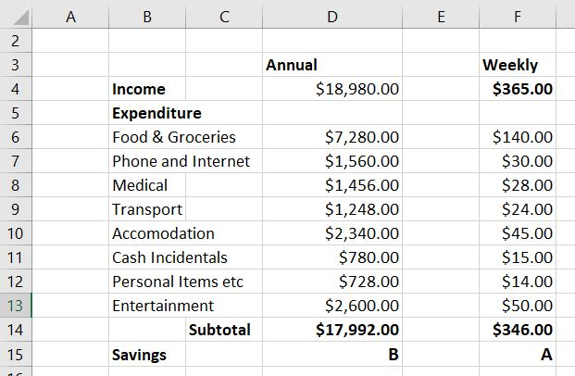
 | - What is the value of B?  ……………………………………………………………………………………………  …………………………………………………………………………………………… | 1
 | - Travis has a sporting injury and finds his medical expenses increase to $65.00 per week.  Suggest some reduction(s) that he could make to areas of discretionary spending to prevent his budget having a weekly loss.  ……………………………………………………………………………………………  ……………………………………………………………………………………………  ……………………………………………………………………………………………  …………………………………………………………………………………………… | 1
Question 18 (2 marks)
In a game, a player draws a card from a pile of cards marked with the letters A to D.
The player then rolls a die numbered from one to six.
Kimberley starts drawing up the table below to find the number of outcomes.
 | A | B | C | D
1 | A1 | B1
2 | A2 | B2
3
4
5
6

 | - Find the probability that a player will obtain the letter B or C with the numeral 5.  ……………………………………………………………………………………………  ……………………………………………………………………………………………  …………………………………………………………………………………………… | 1
 | - Find the probability that a player will obtain a letter other than B and an even number.  ……………………………………………………………………………………………  ……………………………………………………………………………………………  ……………………………………………………………………………………………  …………………………………………………………………………………………… | 1
Question 19 (2 marks)  The average rate for domestic electricity is $0.18/kWh.  Calculate the cost of running an 800-watt air conditioner for 6 hours per day for 90 days.  ……………………………………………………………………………………………  ……………………………………………………………………………………………  ……………………………………………………………………………………………  ……………………………………………………………………………………………  …………………………………………………………………………………………… |  | 2
Question 20 (2 marks)  The masses of the adult female koalas in a colony are normally distributed with a mean of 9.5 kg and a standard deviation of 0.8 kg.  What percentage of these females would you expect to have masses between 7.9 kg and 10.3 kg?  ……………………………………………………………………………………………  ……………………………………………………………………………………………  ……………………………………………………………………………………………  ……………………………………………………………………………………………  …………………………………………………………………………………………… |  | 2

Question 21 (2 marks)
Amelia has this ruler in her pencil case.

 | - What is the absolute error when using this ruler?  ……………………………………………………………………………………………  …………………………………………………………………………………………… | 1
 | - Amelia used the ruler to measure the width of a rectangle as 12.5 cm.  What is the percentage error in this measurement?  ……………………………………………………………………………………………  …………………………………………………………………………………………… | 1
Question 22 (2 marks)
Abigail works for a bank and in the last financial year she was paid an annual retainer of $30 500.
She also earned a commission of 1.2% of the value of the loans that she arranged for customers.
 | - If she arranged loans valued at $5 400 000.00 in the financial year, how much did she earn in total?  ……………………………………………………………………………………………  ……………………………………………………………………………………………  …………………………………………………………………………………………… | 1
 | - In the next financial year, she will be paid an hourly wage that would be equivalent to her earnings in the last financial year if she worked a 40-hour week.  What is her new hourly rate?  ……………………………………………………………………………………………  ……………………………………………………………………………………………  …………………………………………………………………………………………… | 1
Question 23 (2 marks)
Twelve students score the following marks on a test.
Ann | Bea | Carl | Dan | Eddie | Fran | Gil | Hans | Iris | Joe | Kit | Leo
68 | 65 | 70 | 56 | 65 | 72 | 81 | 40 | 69 | 59 | 90 | 69

 | - Calculate the mean of the scores.  ……………………………………………………………………………………………  …………………………………………………………………………………………… | 1
 | - Explain what effect it would have on the mean if Hans’ mark was removed from the data set. You do not need to calculate the revised mean.  ……………………………………………………………………………………………  ……………………………………………………………………………………………  …………………………………………………………………………………………… | 1
Question 24 (3 marks)
Belinda lives in Dubbo, NSW, which is in the Eastern Standard Time zone of UTC + 10.
Felicity lives in Denver, Colorado which has longitude of 105º W.
 | - Use the longitude of Denver to illustrate that it is in the time zone of UTC – 7.  ……………………………………………………………………………………………  ……………………………………………………………………………………………  …………………………………………………………………………………………… | 1
 | - What is the time difference between Dubbo and Denver?  (Include which city is ahead, in your answer).  ……………………………………………………………………………………………  ……………………………………………………………………………………………  …………………………………………………………………………………………… | 1
 | Question 24 continues on page 17
 | - If Belinda makes a call to Felicity at 7:30 am on Friday 5th July (Dubbo time), what will be the local time in Denver when Felicity receives the call?  ……………………………………………………………………………………………  ……………………………………………………………………………………………  …………………………………………………………………………………………… | 1
Question 25 (3 marks)
A network of pipes connects nodes labelled L to R.
The length of each pipe in kilometres is shown.

The owner of the network wants to reduce the number of pipes but still connect all the nodes.
 | - Draw the minimum spanning tree that will achieve the owner’s requirement on the set of nodes below. | 2
 | - What is the minimum length of pipe needed to connect the seven nodes?  ……………………………………………………………………………………………  …………………………………………………………………………………………… | 1
Question 26 (2 marks)  Annabelle plans to rent a car to make a 400 km roundtrip which will take 2 days.  The table below shows data on the two cars that she is considering renting.  Model Rental cost $/day Engine capacity Litres Fuel consumption Litres/100 km Insurance $/ day  Mayotte 3i $60.50 2.3 5.5 $20.50  Kandoi Sporter $58.40 2.5 7.2 $21.40  Fuel costs $1.45/ litre at the time of her trip.  If she includes insurance, which car would cost the least for the trip she is planning and how much would she save by this choice?  ……………………………………………………………………………………………  ……………………………………………………………………………………………  ……………………………………………………………………………………………  ……………………………………………………………………………………………  ……………………………………………………………………………………………  …………………………………………………………………………………………… |  | 2
Question 27 (2 marks)  A hospital uses two different formulae to calculate the dosage for a child aged between 2 and 12, depending on the child’s build.  Young’s Formula:  $$Dosage =\frac{age of child (in years) × adult dosage}{age of child (in years) + 12}$$  Clark’s Formula:  $$Dosage= \frac{weight in kg × adult dosage}{70}$$  A drug called Mazodone has an adult dosage of 45 ml.  Calculate the dosages of Mazodone obtained using each of the formulae for a child who is 11 years of age and who weighs 67 kg.  ……………………………………………………………………………………………  ……………………………………………………………………………………………  ……………………………………………………………………………………………  ……………………………………………………………………………………………  ……………………………………………………………………………………………  ……………………………………………………………………………………………  …………………………………………………………………………………………… |  | 2
Question 28 (2 marks)
The table below gives the amount to which $1 invested in a compound interest account has grown for various periods and interest rates.
 | Compounded values of $1
 | Interest rate per period
Periods | 1.5% | 2.0% | 2.5% | 3.0% | 3.5% | 4.0% | 4.5%
1 | $1.0150 | $1.0200 | $1.0250 | $1.0300 | $1.0350 | $1.0400 | $1.0450
2 | $1.0302 | $1.0404 | $1.0506 | $1.0609 | $1.0712 | $1.0816 | $1.0920
3 | $1.0457 | $1.0612 | $1.0769 | $1.0927 | $1.1087 | $1.1249 | $1.1412
4 | $1.0614 | $1.0824 | $1.1038 | $1.1255 | $1.1475 | $1.1699 | $1.1925
5 | $1.0773 | $1.1041 | $1.1314 | $1.1593 | $1.1877 | $1.2167 | $1.2462
6 | $1.0934 | $1.1262 | $1.1597 | $1.1941 | $1.2293 | $1.2653 | $1.3023
7 | $1.1098 | $1.1487 | $1.1887 | $1.2299 | $1.2723 | $1.3159 | $1.3609

 | - Use the table to calculate the value of $2 300 after it has been invested for 4 years at 3.5% p.a. compounded annually.  ……………………………………………………………………………………………  …………………………………………………………………………………………… | 1
 | - What amount of money, when invested for 6 years at 4.5% p.a., grows to $36 464.40.  ……………………………………………………………………………………………  …………………………………………………………………………………………… | 1

Question 29 (3 marks)
Hannah uses the equation to model the height of a ball tossed into the air from ground level and allowed to fall under gravity (with air resistance ignored).
Here h is the height of the ball in metres and t is the time elapsed in seconds.
 | Hannah uses graphing software to draw the following graph of the equation.  Hannah knows that only part of this curve applies to her model for the height of the ball.  - Between what values of t does the graph model the height of the ball?  …………………………………………………………………………………………… | 1
 | - What is the maximum height that the ball reaches?  …………………………………………………………………………………………… | 1
 | - For how many seconds is the ball more than 25 metres from the ground?  ……………………………………………………………………………………………  …………………………………………………………………………………………… | 1
Question 30 (3 marks)
The diagram shows the flow of water from a dam (D), through pipes to a series of filtration stations (W, X Y and Z), and on to a reservoir (R).

The weights on each edge represent the capacity in gigalitres of each pipe.
 | - What is the excess capacity of the pipe DW?  ……………………………………………………………………………………………  …………………………………………………………………………………………… | 1
 | - What is the maximum flow from the dam to the reservoir?  ……………………………………………………………………………………………  ……………………………………………………………………………………………  ……………………………………………………………………………………………  …………………………………………………………………………………………… | 2
Question 31 (2 marks)
The graph shows the velocity (v) over time (t) of a ball which is rolling in a straight line.
It is accelerating at a constant rate.

 | - What is the gradient of the line?  ……………………………………………………………………………………………  ……………………………………………………………………………………………  …………………………………………………………………………………………… | 1
 | - Write the equation of the line in the form  ……………………………………………………………………………………………  ……………………………………………………………………………………………  ……………………………………………………………………………………………  …………………………………………………………………………………………… | 1
Question 32 (2 marks)
The graph below shows the depreciating value of a laptop, using the declining-balance method, over a period of 5 years.

 | - Determine the annual percentage rate of depreciation.  ……………………………………………………………………………………………  ……………………………………………………………………………………………  …………………………………………………………………………………………… | 1
 | - Calculate the value of the laptop after 6 years.  ……………………………………………………………………………………………  ……………………………………………………………………………………………  …………………………………………………………………………………………… | 1
 | Question 33 (2 marks)  The diagram below shows the seven suburbs of a city and the network of public transport links between them.  The amounts represent the cost (in dollars) of travel using that link.  Calculate the minimum cost of travelling from G to C and list the path which achieves this cost.  ……………………………………………………………………………………………  ……………………………………………………………………………………………  ……………………………………………………………………………………………  ……………………………………………………………………………………………  ……………………………………………………………………………………………  …………………………………………………………………………………………… | 2
Question 34 (2 marks)
The line with equation is shown on the number plane below.

 | - On the same number plane, draw the graph of .  ……………………………………………………………………………………………  ……………………………………………………………………………………………  …………………………………………………………………………………………… | 1
 | - Give the solution to the simultaneous equations and .  ……………………………………………………………………………………………  …………………………………………………………………………………………… | 1
Question 35 (3 marks)
When rain falls on the roof below, the water is is directed to a cylindrical tank.
No water is collected from the top of the tank.

 | - How many cubic metres of water would be collected when there is a fall of 60 mm of rain, assuming there is no wastage.  ……………………………………………………………………………………………  ……………………………………………………………………………………………  …………………………………………………………………………………………… | 2
 | - The tank has a diameter of 6 metres.  How much would the water level in the tank rise after the rainfall above?  ……………………………………………………………………………………………  ……………………………………………………………………………………………  …………………………………………………………………………………………… | 1

Question 36 (2 marks)
The box plot below shows the distribution of class sizes (number of students) in a school which has 64 separate classes.

 | - How many classes had a size greater than 22 students?  ……………………………………………………………………………………………  …………………………………………………………………………………………… | 1
 | - How many classes had a size between 10 students and 22 students?  ……………………………………………………………………………………………  …………………………………………………………………………………………… | 1
Question 37 (2 marks)
A car was bought for $48 500 on 1st July 2016 and depreciates using the straight-line method.
It’s value on 1st July 2018 was $33 950.
 | - What percentage of its original value does it lose each year?  ……………………………………………………………………………………………  ……………………………………………………………………………………………  …………………………………………………………………………………………… | 1
 | - What would be its value on 1st July 2021?  ……………………………………………………………………………………………  ……………………………………………………………………………………………  …………………………………………………………………………………………… | 1

Question 38 (3 marks)
A clothing manufacturer makes T- shirts and has daily costs of rent, electricity etc which add up to $120.00.
It costs $8.00 to make each T-shirt in materials and labour.
The T-shirts sell to retailers for $20.00 each.
 | - The daily income function for the T-shirts iswhere n is the number of the T-shirts made each day.  What is the daily cost function of the T-shirts?  ……………………………………………………………………………………………  ……………………………………………………………………………………………  ……………………………………………………………………………………………  …………………………………………………………………………………………… | 1
 | - The daily income function has been drawn on the number plane below.  Draw the daily cost function on the same graph.  ……………………………………………………………………………………………  …………………………………………………………………………………………… | 1
 | Question 38 continues on page 30
 | - Determine the daily break-even point after which the manufacturer will begin to make a profit.  ……………………………………………………………………………………………  ……………………………………………………………………………………………  ……………………………………………………………………………………………  …………………………………………………………………………………………… | 1
Question 39 (2 marks)  A triangle ABC has sides of 8 cm, 12 cm and 15 cm.  Heron’s formula gives the area of a triangle as , where .  Use the formula to calculate the area of the triangle ABC, correct to 3 significant figures.  ……………………………………………………………………………………………  ……………………………………………………………………………………………  ……………………………………………………………………………………………  ……………………………………………………………………………………………  …………………………………………………………………………………………… |  | 2
Question 40 (2 marks)
In a promotion for a sporting team, fans choose one token from each of three barrels.
The tokens are coloured Black, White and Orange and the tree diagram below shows the proportion of colours in each barrel.

 | - What is the probability that a fan chooses three White tokens?  ……………………………………………………………………………………………  …………………………………………………………………………………………… | 1
 | - What is the probability that a fan chooses one token of each colour?  ……………………………………………………………………………………………  ……………………………………………………………………………………………  …………………………………………………………………………………………… | 1
Question 41 (2 marks)
The scale drawing shows the residential blocks on either side of Henderson St.

 | - Calculate the area of block number 27.  ……………………………………………………………………………………………  …………………………………………………………………………………………… | 1
 | - Block number 22 is to be fenced on all sides with metal fencing that costs $40.50 per metre.  The owners of numbers 20 and 24 agree to pay half the cost of their common boundaries.  Calculate the cost of fencing block number 22.  ……………………………………………………………………………………………  ……………………………………………………………………………………………  ……………………………………………………………………………………………  …………………………………………………………………………………………… | 1
Question 42 (3 marks)
A machine produces spherical bearings which have a mean diameter of 8.8 mm and a standard deviation of 0.15 mm.
 | - Any bearings which have a diameter greater than 9.1 mm or less than 8.5 mm must be discarded.  What percentage of bearings would be discarded?  ……………………………………………………………………………………………  ……………………………………………………………………………………………  ……………………………………………………………………………………………  …………………………………………………………………………………………… | 1
 | - The company wants to improve the accuracy of its machine, so that only 0.3% of the bearings are discarded.  What new standard deviation would need to be achieved?  ……………………………………………………………………………………………  ……………………………………………………………………………………………  ……………………………………………………………………………………………  …………………………………………………………………………………………… | 2

Question 43 (2 marks)
 | A directed network is represented by the table below.  To  P Q R S T  From P - 4 7 - 5  Q 7 - 3 - -  R - - - 2 6  S 3 - - - 4  T 7 - - 5 -  Draw the network in the space below. | 2
Question 44 (3 marks)
The table below gives the future value of an annuity of $1 per period for various periods and interest rates.

Table of Future Value Interest Factors
r | 0.0025 | 0.0030 | 0.0035 | 0.0040 | 0.0045 | 0.0050 | 0.0055 | 0.0060
53 | 56.5961 | 57.3530 | 58.1230 | 58.9063 | 59.7033 | 60.5141 | 61.3391 | 62.1785
54 | 57.7376 | 58.5250 | 59.3264 | 60.1419 | 60.9719 | 61.8167 | 62.6765 | 63.5516
55 | 58.8819 | 59.7006 | 60.5340 | 61.3825 | 62.2463 | 63.1258 | 64.0212 | 64.9329
56 | 60.0291 | 60.8797 | 61.7459 | 62.6280 | 63.5264 | 64.4414 | 65.3733 | 66.3225
57 | 61.1792 | 62.0624 | 62.9620 | 63.8786 | 64.8123 | 65.7636 | 66.7329 | 67.7204
58 | 62.3322 | 63.2485 | 64.1824 | 65.1341 | 66.1040 | 67.0924 | 68.0999 | 69.1267
59 | 63.4880 | 64.4383 | 65.4070 | 66.3946 | 67.4014 | 68.4279 | 69.4744 | 70.5415
60 | 64.6467 | 65.6316 | 66.6359 | 67.6602 | 68.7047 | 69.7700 | 70.8565 | 71.9647
61 | 65.8083 | 66.8285 | 67.8692 | 68.9308 | 70.0139 | 71.1189 | 72.2463 | 73.3965
62 | 66.9729 | 68.0290 | 69.1067 | 70.2065 | 71.3290 | 72.4745 | 73.6436 | 74.8369
63 | 68.1403 | 69.2331 | 70.3486 | 71.4874 | 72.6499 | 73.8368 | 75.0487 | 76.2859
64 | 69.3106 | 70.4408 | 71.5948 | 72.7733 | 73.9769 | 75.2060 | 76.4614 | 77.7436
65 | 70.4839 | 71.6521 | 72.8454 | 74.0644 | 75.3098 | 76.5821 | 77.8820 | 79.2101
66 | 71.6601 | 72.8670 | 74.1004 | 75.3607 | 76.6487 | 77.9650 | 79.3103 | 80.6854

 | - Shaun invests $450 per month in an annuity which pays 3.6% p.a. compounding monthly. What will be the value of the annuity after 62 months?  ……………………………………………………………………………………………  ……………………………………………………………………………………………  …………………………………………………………………………………………… | 1
 | - An annuity has a value of $64 000 after being invested for four and a half years at a rate of 6.6% p.a., compounded monthly.  How much was invested in the annuity each month?  ……………………………………………………………………………………………  ……………………………………………………………………………………………  ……………………………………………………………………………………………  ……………………………………………………………………………………………  …………………………………………………………………………………………… | 2
Question 45 (4 marks)
A roller for an appliance is in the shape of a cylinder with hemispherical indents cut out of each end.

 | - Calculate the volume of the roller to the nearest cubic centimetre.  ……………………………………………………………………………………………  ……………………………………………………………………………………………  …………………………………………………………………………………………… | 2
 | - The roller is to be manufactured from aluminium.  Aluminium has a density of 2 700 kg/m³.  Calculate the mass of aluminium required to manufacture 200 rollers.  ……………………………………………………………………………………………  ……………………………………………………………………………………………  ……………………………………………………………………………………………  ……………………………………………………………………………………………  ……………………………………………………………………………………………  …………………………………………………………………………………………… | 2
Question 46 (4 marks)
A network diagram has been drawn outlining the activities in the process of manufacturing a product.
Each activity has its duration (in days) listed beside it.

 | - A forward scan has been started in the boxes above each vertex.  By completing the forward scan, find the critical time for the process.  ……………………………………………………………………………………………  …………………………………………………………………………………………… | 1
 | - Complete a backward scan and list the critical path for the process.  ……………………………………………………………………………………………  …………………………………………………………………………………………… | 1
 | - Find the float time for activity O  ……………………………………………………………………………………………  …………………………………………………………………………………………… | 1
Question 47 (3 marks)
A helicopter H, hovers 60 metres directly above a point C which is on the same level as the deck of a yacht.
When the mast of the yacht TD is vertical, measurements are taken from the helicopter.
The angle of depression from H to T is 26º and the angle of depression from H to D is 42º.

 | - Explain why  ……………………………………………………………………………………………  ……………………………………………………………………………………………  …………………………………………………………………………………………… | 1
 | - Calculate the distance DH.  ……………………………………………………………………………………………  ……………………………………………………………………………………………  …………………………………………………………………………………………… | 1
 | - Calculate the height of the mast TD.  ……………………………………………………………………………………………  ……………………………………………………………………………………………  ……………………………………………………………………………………………  ……………………………………………………………………………………………  …………………………………………………………………………………………… | 1
Question 48 (5 marks)
A zoologist collects data on the lengths of the fore-limb (F) and rear-limb (R) of a native marsupial called a woylie.
The data has been plotted on the scatterplot below.

 | - Draw a line of best fit on the scatterplot.  This can be done by eye. | 1
 | - What is the intercept on the vertical axis of your line of best fit (to the nearest whole number)?  …………………………………………………………………………………………… | 1
 | - What is the gradient of your line of best fit (to the nearest whole number).  ……………………………………………………………………………………………  …………………………………………………………………………………………… | 1
 | - Determine the equation of your line of best fit and use this to calculate the length of the rear-limb of a woylie which has a fore-limb which is 6 cm long.  ……………………………………………………………………………………………  ……………………………………………………………………………………………  …………………………………………………………………………………………… | 2
Question 49 (4 marks)
Heather takes out a loan of $30 000 which has interest calculated monthly and repayments of $500.00 deducted after the interest is added.
Interest is calculated using the formula: .
Heather draws up the table below, to show the progress of the loan over the first six months.
N | P | I | P + I | P + I - R
1 | $30 000.00 | $200.00 | $30 200.00 | $29 700.00
2 | $29 700.00 | $198.00 | $29 898.00 | $29 398.00
3 | $29 398.00 | $195.99 | $29 593.99 | $29 093.99
4 | $29 093.99 | $193.96 | $29 287.95 | $28 787.95
5 | $28 787.95 | $191.92 | $28 979.87 | $28 479.87
6 | $28 479.87 | $189.87 | $28 669.73 | $28 169.73

 | - What is the annual interest rate as a percentage?  ……………………………………………………………………………………………  ……………………………………………………………………………………………  ……………………………………………………………………………………………  …………………………………………………………………………………………… | 2
 | - What is the principal at the start of the 8th year?  ……………………………………………………………………………………………  ……………………………………………………………………………………………  ……………………………………………………………………………………………  …………………………………………………………………………………………… | 2
 | End of Examination

Section II Extra writing space

If you use this space, clearly indicate which question you are answering.

2019 Trial Higher School Certificate Examination

Mathematics Standard 2

REFERENCE SHEET

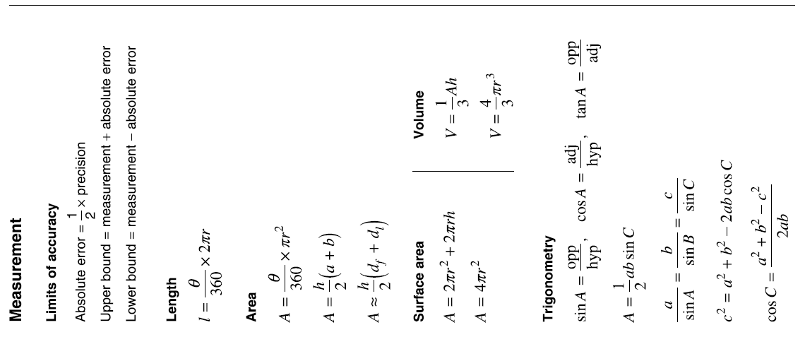
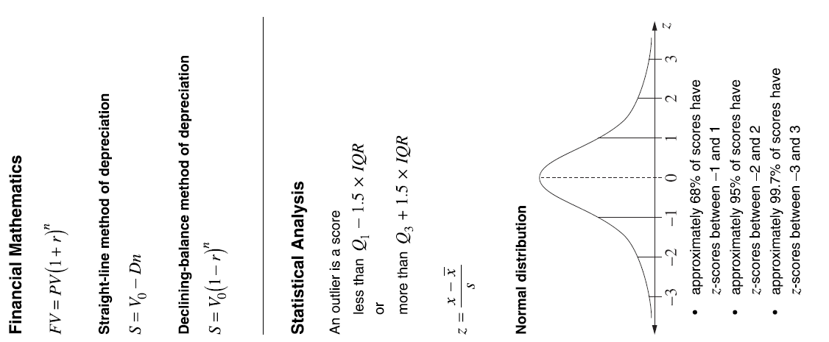

School/College
2019 Trial Higher School Certificate Examination
Mathematics Standard 2

Name ________________________________ Teacher ________________________

Section I – Multiple Choice Answer Sheet

Allow about 25 minutes for this section
Select the alternative A, B, C or D that best answers the question. Fill in the response oval completely.

Sample: | 2 + 4 = | (A) 2 | (B) 6 | (C) 8 | (D) 9
 |  | A | B | C | D

If you think you have made a mistake, put a cross through the incorrect answer and fill in the new answer.

 |  | A | B | C | D

If you change your mind and have crossed out what you consider to be the correct answer, then indicate the correct answer by writing the word correct and drawing an arrow as follows.

 |  | A | B 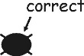 | C | D

1. A B C D
2. A B C D
3. A B C D
4. A B C D
5. A B C D
6. A B C D
7. A B C D
8. A B C D
9. A B C D
10. A B C D
11. A B C D
12. A B C D
13. A B C D
14. A B C D
15. A B C D

